Inference :

Dependent variable : Personal Loan .

Independent variable : Income , CCAvg , Education .

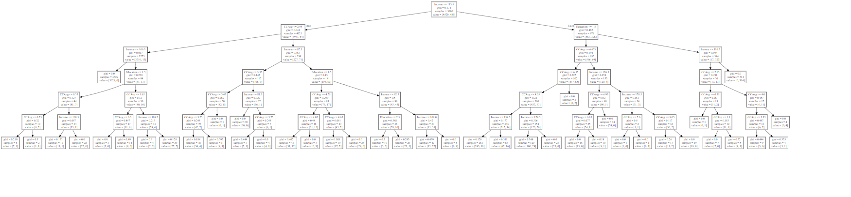

-> 1 Person having CCAvg below ,25 and education below 1.5 have got loan.

-> 6 people having CCAvg below 1.65 and education below 1.5 have got loan.

-> 2 people having income lesser than 108.5 and CCAvg between 1.5 and 1.65 have got loan.

-> 3 people having CCAvg lesser than 3.45 and income 82.5 have got loan.

-> 12 people having CCAVG below 4.05 and education below 1.5 and income between 82.5 and 113.5 have got loan.

-> 5 people having education below 2.5 and income 92.5 and education below 1.5 have got loan.

-> 18 people having income below 159.5 and education below 1.5 and CCAvg 4.05 have got loan.

-> 29 people having income 179.5 and CCAvg between 6.55 and 4.05 have got loan.

-> 1 person having CCAvg between 6.85 and 6.95 and income 176.5 have got loan.

-> 7 person having CCAvg below 1.1 and income below 116.5 have got loan.

-> 3 person having CCAvg below 3.35 and income below 116.5 have got loan.